ANNEXURE A (ASSESSMENT TOOL 1)
APPLICATION BASED QUESTIONS
NAME: VIJAYALAKSHMI S
REG NO: 192472326
QUESTION 1
A smart city surveillance system
1. Identify
- Continuous video data is transferred between I/O devices, Memory, and CPU.
- During peak hours, data traffic increases.
- CPU waits for memory and I/O operations, causing delays in threat detection.

2. Analyze
The CPU processes instructions while memory stores data and I/O devices continuously send video frames. In a single-bus architecture, all components share one communication path, creating congestion. This increases waiting time and reduces processing speed. A multi-bus architecture allows simultaneous communication, reducing delays and improving system performance.

3. Compare
Feature | Single Bus | Multi Bus
Data Transfer | One transfer at a time | Multiple transfers simultaneously
Speed | Slow | Fast
Cost | Low | High
Performance | Lower | Higher
Traffic Congestion | High | Low

4. Calculate (If Applicable)
Assume:
- CPU Execution = 4 ms
- Memory Access = 5 ms
- I/O Transfer = 6 ms
Single Bus
Total Time = 4 + 5 + 6
= 15 ms
Multi Bus
Memory and I/O occur simultaneously.
Total Time = 6 + 4
= 10 ms
Performance Improvement
$$\frac{15-10}{15}×100=33.3\%$$

5. Evaluate / Recommend
- Use Multi-Bus Architecture
- Implement Cache Memory
- Use DMA (Direct Memory Access)
- Apply Instruction Pipelining
- Increase CPU clock speed

6. Justify
Multi-bus architecture reduces communication bottlenecks. Cache memory minimizes memory access delays, and pipelining improves instruction throughput. Together they increase system responsiveness.

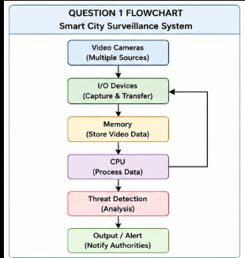

QUESTION 2
Real-time Stock Trading Application
1. Identify
- High CPI
- Frequent memory access
- Branch instructions
- Slow transaction processing

2. Analyze
The CPU repeatedly performs Fetch → Decode → Execute cycles. Frequent memory accesses and branch instructions cause pipeline stalls, increasing CPI and execution time.

3. Compare
Without Optimization | With Optimization
High CPI | Low CPI
More stalls | Fewer stalls
Slow execution | Faster execution
Low throughput | High throughput

4. Calculate
Formula
$$CPU Time=Instructions×CPI×Clock Cycle$$
Example
Instructions = 5 Million
Clock Cycle = 2 ns
Before
CPI = 4
CPU Time
= 5×10⁶ ×4×2 ns
= 40 ms
After
CPI = 2
CPU Time
= 5×10⁶ ×2×2 ns
= 20 ms
Performance Improved = 50%

5. Evaluate / Recommend
- Cache Memory
- Branch Prediction
- Instruction Pipelining
- Out-of-order Execution
- Prefetching

6. Justify
Reducing CPI directly lowers CPU execution time, improving transaction speed and system efficiency.
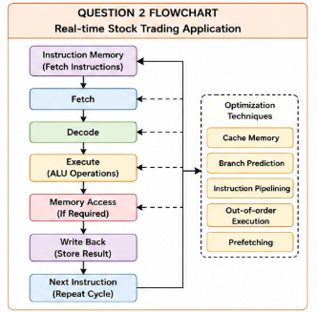
QUESTION 3
8085 Temperature Control System
1. Identify
- Incorrect addressing mode
- Wrong sensor readings
- Incorrect actuator response

2. Analyze
Different addressing modes determine how data is accessed. Choosing the wrong mode accesses incorrect memory locations, resulting in incorrect temperature processing.

3. Compare
Addressing Mode | Description | Example
Immediate | Data inside instruction | MVI A,25H
Direct | Address specified | LDA 2050H
Register | Uses register | MOV A,B
Register Indirect | Address stored in register pair | MOV A,M

4. Calculate
Sensor Temperature
55°C
Stored at Memory Location
2050H
Correct Instruction
LDA 2050H
Wrong Instruction
MVI A,55H
Incorrect data may be loaded if actual sensor value changes.

5. Evaluate / Recommend
- Use Direct Addressing for sensor values
- Validate memory locations
- Test instructions before deployment

6. Justify
Correct addressing modes ensure accurate sensor readings and reliable industrial automation.
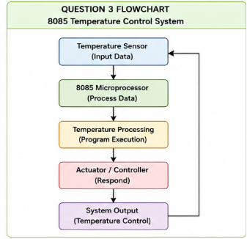

QUESTION 4
8086 Segmented Memory
1. Identify
- Stack overflow
- Incorrect data access
- Segment register errors

2. Analyze
8086 divides memory into:
- Code Segment (CS)
- Data Segment (DS)
- Stack Segment (SS)
- Extra Segment (ES)
Improper initialization causes invalid memory access and stack overflow.

3. Compare
Segment | Purpose
CS | Stores instructions
DS | Stores variables
SS | Stores stack
ES | Stores extra data

4. Calculate
Physical Address Formula
Physical Address

= Segment ×16 + Offset
Example
Segment = 2500H
Offset = 1000H
Physical Address
2500H ×16

=25000H
25000H+1000H
=26000H

5. Evaluate / Recommend
- Properly initialize CS, DS, SS
- Allocate sufficient stack space
- Use correct addressing modes
- Validate segment registers

6. Justify
Proper segmentation prevents memory corruption and ensures reliable multitasking.
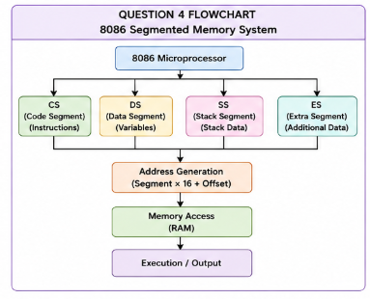

QUESTION 5
Hexadecimal and Binary Conversion
1. Identify
- Wrong hexadecimal interpretation
- Incorrect binary conversion
- Incorrect instruction execution

2. Analyze
The CPU processes binary data internally. Incorrect hexadecimal conversion changes instruction values, causing processing errors.

3. Compare
Hexadecimal | Binary
0–F | 0000–1111
Compact | Larger representation
Easy debugging | CPU processing format

4. Calculate
Convert
3AH
Binary
3 =0011
A =1010
3AH
=00111010
Convert
5FH
Binary
5=0101
F=1111
5FH
=01011111

5. Evaluate / Recommend
- Use automatic conversion tools
- Verify hexadecimal values before execution
- Benchmark CPU performance
- Perform error checking

6. Justify
Accurate number conversion prevents execution errors and improves debugging efficiency in real-time systems.
